

American International University-Bangladesh (AIUB)  
**Department of Computer Science  
Fall 19_20  
CSC 2210 Object Oriented Analysis and Design (OOAD)**

**Section: N  
Group No: 11**

**Tour Easy**

An Object-Oriented Analysis and Design (OOAD) project submitted

By

*Mahfuzul Alam (18-36746-1)*

|  |  |
| --- | --- |
| **CO3:** Formulate a baseline document to perform feasibility study of a proposed project idea | Total Marks |
|  |
| Project Background Analysis [5] |  |
| Project Content Knowledge [5] |  |
| Project Feasibility Study [5] |  |
| **CO4:** Design a Complex engineering problem using UML Tools and explain the system using a project report and presentation | Total Marks |
|  |
| Diagram Standard [5] |  |
| Report Organization [5] |  |
| Presentation Delivery [5] |  |

1. **PROBLEM DOMAIN**

1.Write the background description that helps putting the project into the right context of a problem domain and gives everyone involved a common view of the project

-

Number of Bangladeshi tourists are increasing day by day in bangladesh. But planning and doing tour can be a complicated process for tourist and tourism business. We are trying to solve that problem with this project .We want to make the touring process easier and more convenient to people.We will focus more on group touring(because most people likely to do group touring according to our feasibility study).We might have some security feature for enhancing security. We will partner with third party hotel/transportation businesses to provide the services.

2.What is the root cause of this problem? why is this problem is so important to consider?

>

The root cause of the problem is the tourism industry is not digitized yet . Digitizing the tourism industry will simplify the touring process.Solving the problem might increase tourism.It might also solve bangladesh's low number of forgein tourists (Bangladesh has the highest locals per tourists in the world which is 1273 locals per one tourist, second place got under 400).Digitalizing tourist industry will also help with the security .

* 1. **Project Solution and Feasibility Analysis**

3.What are the solutions you are going to propose to deal with the problem? why is this   
 solution is particularly appropriate to solve the problem? Is the solution feasible to the   
 meet the business objective?

-

To solve the problem, it needs a software system that is easy to use and attractive for the user. This software system needs to offer more features than present software. Proposed software system will offer Pre-Planed Packages so that it can be helpful for the user. If user don’t like Pre-Planed packages then user can create their own packages and post it on the system so that another user can find it and if they like, they can join. To build trust, this system will offer some safety features like this system will store each and every detail of every tour with every members NID details. But this type of information will be privately stored. According to the survey, This solution will be the best for the problem.

ALTERNATIVE -

We need to make a software/system that will build an attraction to the tourists. Tourists can also join our Pre-planned packages through the system according to their budget and touring spot preferences. We find these problems by our survey, most of the people are facing these kinds of problems, so we think our system will be appropriate to solve these problems. Yes, these solutions are feasible to meet the business objectives.

4.Provide a short description of the software being specified and its purpose, including relevant benefits, objectives, and goals

-

TourEasy is a very first and advance tour helping software system. If you want a reliable, secure Tour Assistant then TourEasy is for you. Tour easy can make your tour easy. TourEasy can Book hotels and food menu for you. TourEasy can find you the best tour mate for you. TourEasy is the best tour solution in our country. TourEasy can connect people from every place in our country. TourEasy makes your Tour the best Tour.

TourEasy is not only beneficial for the tourists but also for everyone related to the tour. Like Hotel management, Tour Guides will also be beneficial with TourEasy. TourEasy can create unlimited opportunities for small businesses. TourEasy is the best for our country. TourEasy can also affect our national economy. TourEasy is just a start for unlimited new opportunities. In future TourEasy can make a big change in tour agency.

ALTERNATIVE-

-Introducing TourEasy!

TourEasy is everything that you have been missing in your tour till now. Be it tour plan or choosing exciting tour packages with TourEasy, you can do it all. Book hotels, choose guides and make plans with this system. Tour anywhere in Bangladesh, in unknown places we provide you guide to make your trip easier. You can pay through local cards or the international one. TourEasy offers you so many options that you simply can’t believe!

5.Existing studies presented in the problem area. What are the existing software solutions   
 are available to solve the aforementioned problem?

-

Some of the existing touring software solutions are -

> Trip Advisor

>klook

They offer services as

>>Tour-spot’s reviews.

>>Booking hotels .

>>Booking Restaurants.

But what lacks in those programs are -

>>Services are limited , those apps won’t offer transportation optionalities so you’ll have to use some other systems for managing transport options .

>>Planning your tour according to your budget.

>>Options of choosing relevant guides.

>>Those don’t work in Bangladesh.

6.What makes this project new, innovative, interesting, or otherwise distinct from other similar projects? Does the project duplicate functionality already available in the market?

-

Facts that make this project new, innovative, interesting, or otherwise distinct from other similar projects are -

>>This project will create a community of fellow tourists where you can tour together with matched preferences

>>This offers services like getting reviews of a tour spots, Pre-planning every things related to touring under a system which includes booking hotels, restaurants, transportation , preferred duration, guides facilities etc . And these facilities are flexible too so it will depend on the user to choose how he/she wants to travel.

>>Travelers general information are stored for security purposes .

>>Options of managing plans according to your budget.

1. **UML DIAGRAM**
   1. **Use Case Diagram**
   * Does the Use Case diagram include the major use cases, actors who perform the use cases and the relationships among the use cases needed to deliver by the system?

-

Yes, It includes all the major use cases like login , tour package selection, ordering package ,payment . It includes performing actor such as traveler , system admin and accountant. Also there are include relationships between - tour spot , transportation medium and package selection ; ordering package includes verifying ; browse tour includes package selection ; and extended relationship between package selection and hotel, guide selection ; payment and pay by cash, pay by cards.

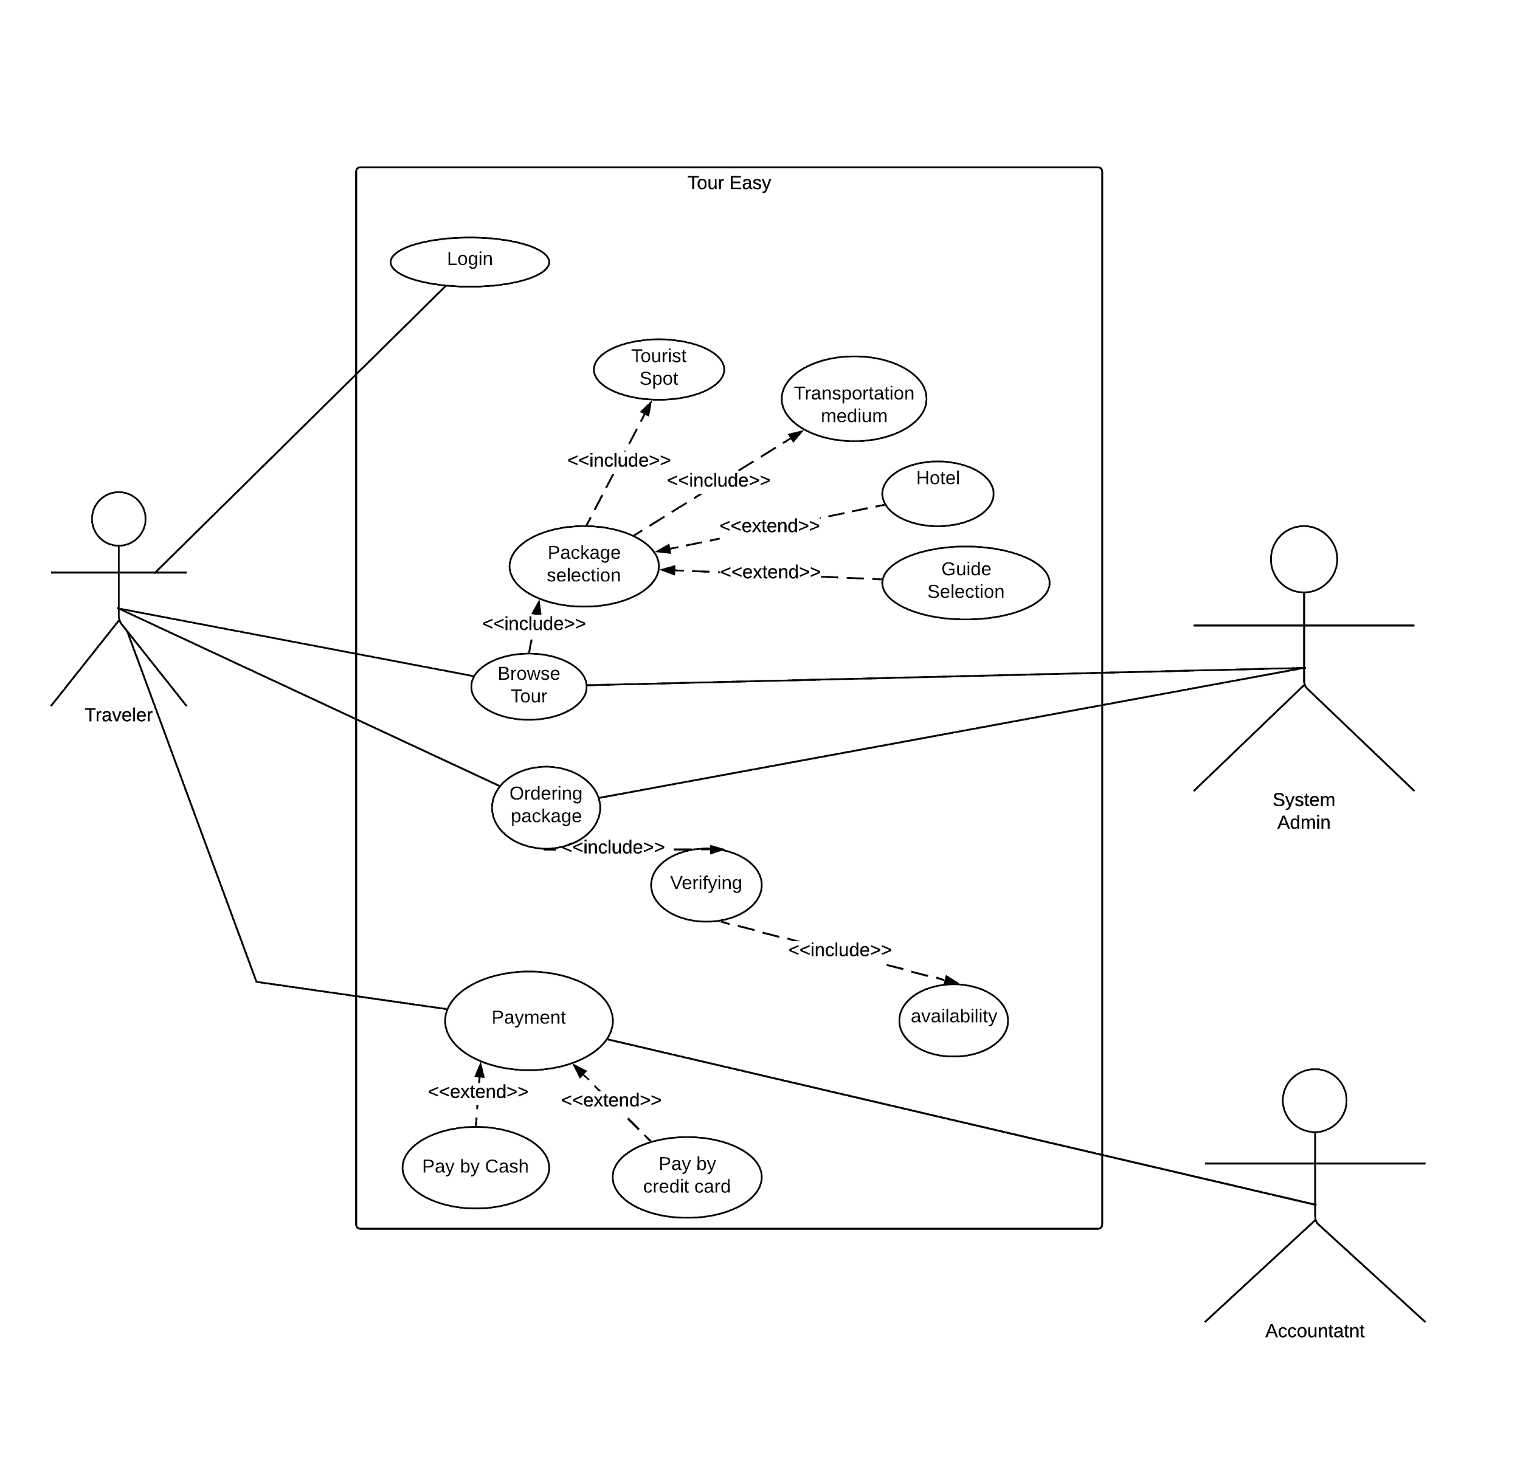

**2.2Class Diagram**

* Does the Class diagram include the major classes (attributes, operations) and the relationship among the classes needed to deliver by the system?

-Yes ,It does.

* 1. **Activity Diagram**
* Does the Activity diagram include the major activities needed to deliver by the system?

-Yes

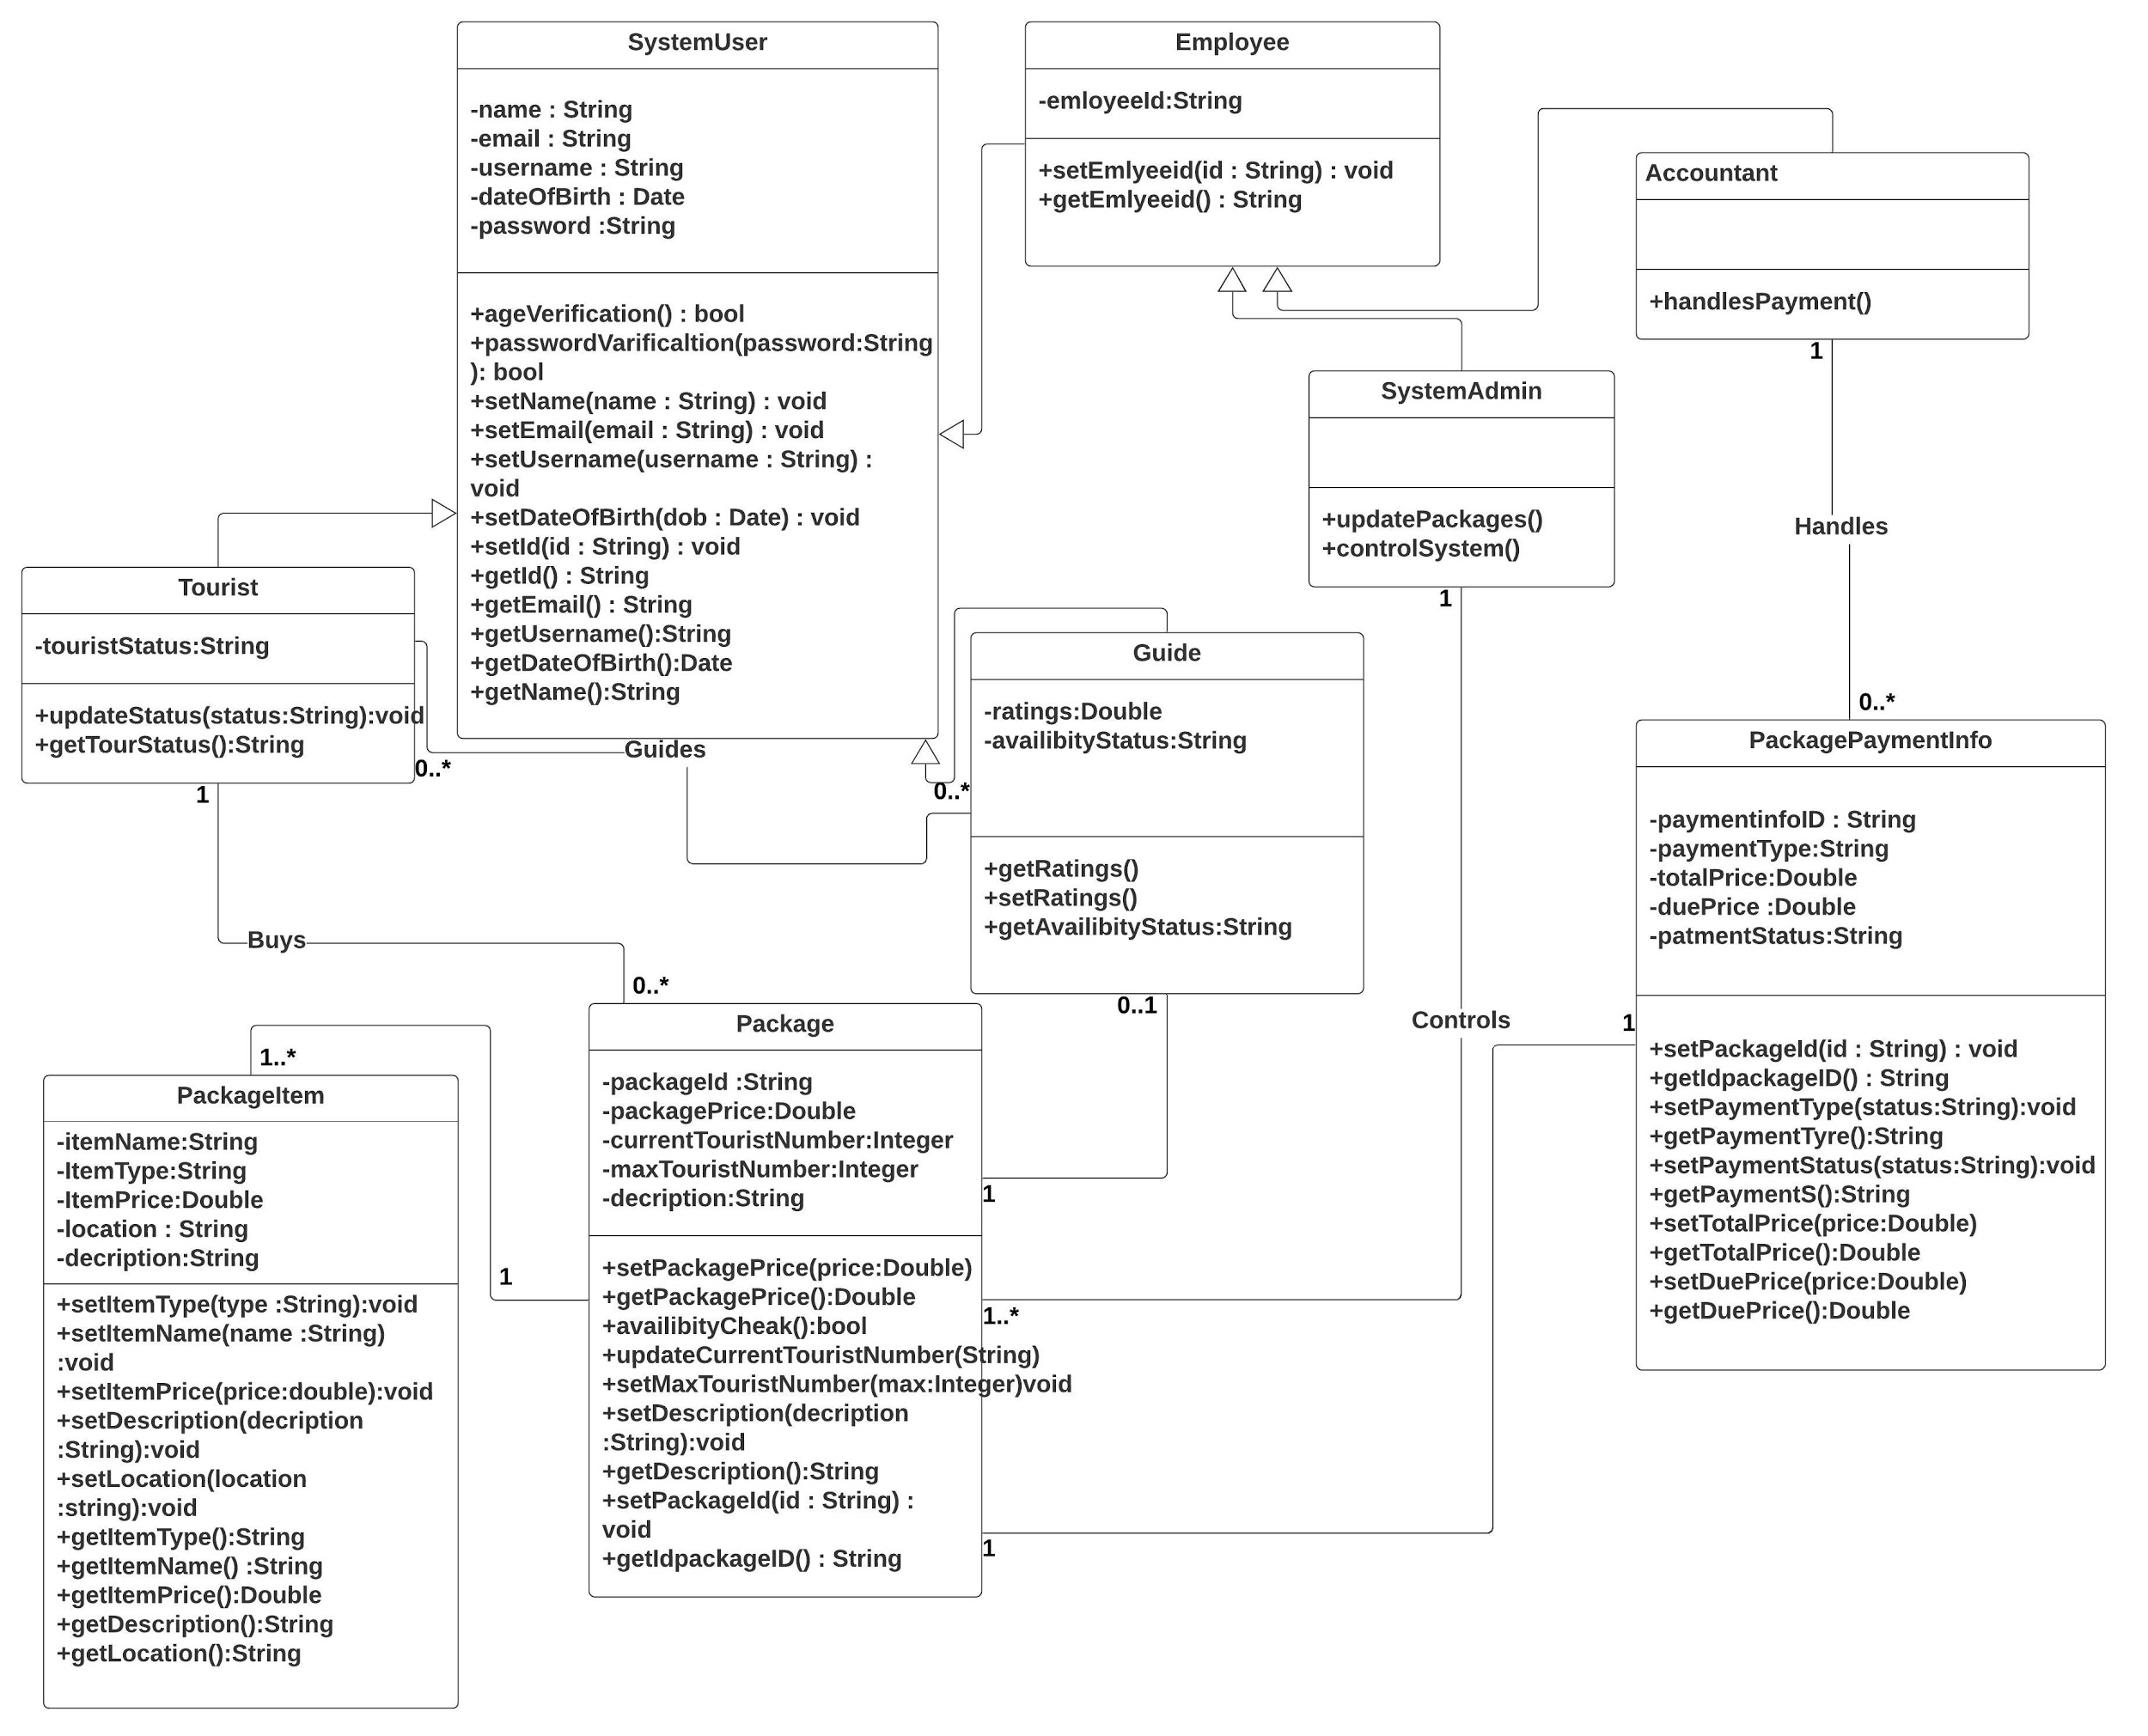

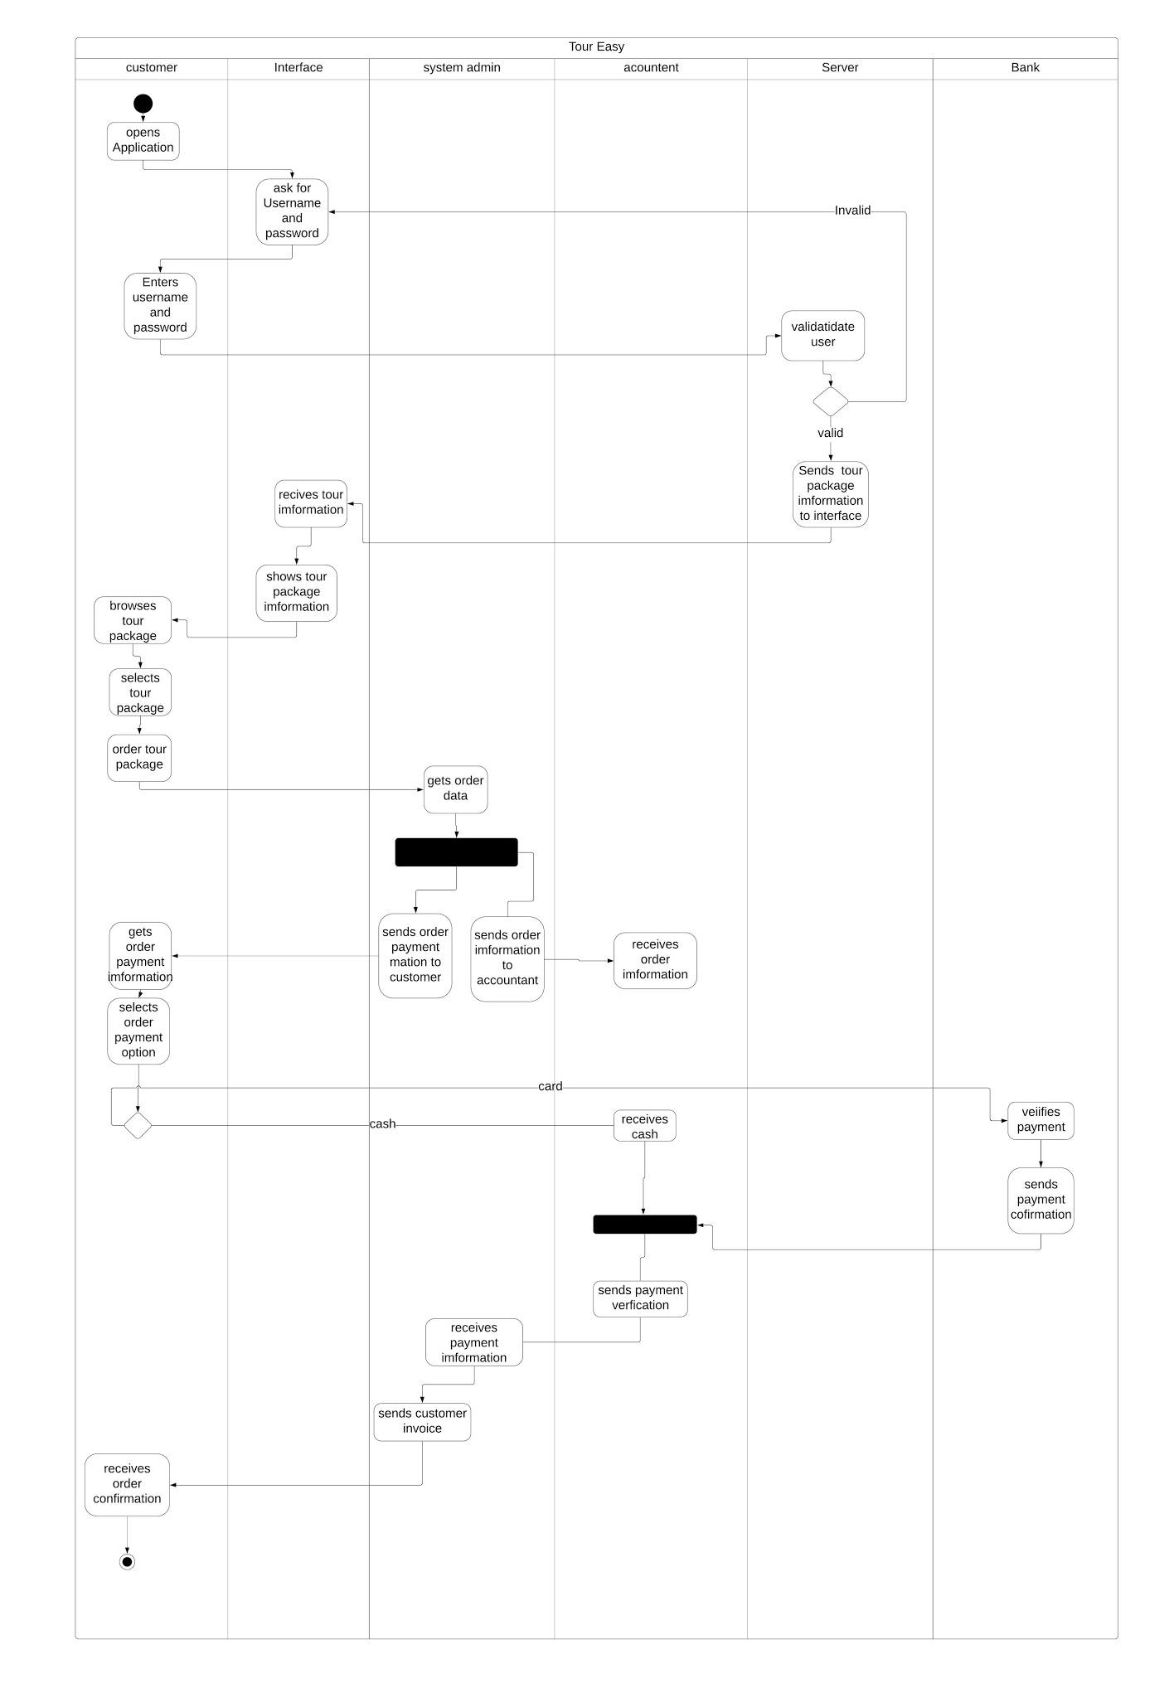

* 1. **Sequence Diagram**
* Does the Sequence diagram include the sequence of the major activities needed to deliver by the system?

-We have multiple sequence diagram depending on the different major activities

